

**Adigrat University**

**College Of Engineering And technology**

**Department Of Software Engineering**

**Project Proposal On**

**Clinic Management System (CMS)**

**For Adigrat University**

A PROJECT PROPOSAL SUBMITTED TO THE DEPARTMENT OF SOFTWARE ENGINEERIMG OF ADIGRAT UNIVERSITY IN PARTIAL FULFILMENT OF THE REQUIREMENTS FOR THE DEGREE OF BACHELOR OF SCIENCE IN SOFTWARE ENGINEERIMG.

**MembersName ID**

1. **Alem Eyasu RET/10730/11**
2. **Alemseged Hafte RET/11751/11**
3. **Dawit Kinfe RET/10399/11**
4. **Berihu Weldu RET/11765/11**
5. **Eyerusalem kiflom RET/11336/11**
6. **Eyeru mezgebe RET/14443/11**

**Advisors: Ins. Equbay G. (MSc)**

**Adigrat, Ethiopia**

**January 03, 2024**

# Executive Summary

In many healthcare facilities, the current manual system for managing clinic operations poses challenges in patient registration, information storage, and resource tracking. This executive summary introduces an innovative solution – the Clinic Management System (CMS), an ERP-based automated platform designed to revolutionize clinic administration.

**Objective:**

The primary goal of the CMS is to streamline and enhance the efficiency of clinic operations by automating various tasks associated with patient management, resource tracking, and communication among different modules.

**Key Features:**

Patient Information Management: The CMS offers a secure and centralized repository for storing patient details, eliminating the reliance on easily destructible cards. It ensures easy access, retrieval, and organization of patient information.

**Resource Tracking:** The system integrates all clinic resources, including medicines, into a single application. This not only simplifies resource management but also facilitates quick decision-making by providing a comprehensive overview of available resources.

**Efficient Communication:** The CMS allows seamless communication and information transfer between different modules, promoting collaboration among clinic staff. This ensures a coordinated approach to patient care and resource utilization.

**Benefits:**

Enhanced Efficiency: By automating manual processes, the CMS reduces the time taken for service delivery, improving overall efficiency in clinic operations.

**Improved Patient Care:** Quick access to patient information enables healthcare providers to deliver more personalized and timely care to patients, ultimately enhancing the quality of healthcare services.

**Data Security:** The centralized data repository ensures the security and integrity of patient information, minimizing the risk of data loss or unauthorized access.

Contents

Executive Summary ii

List of Tables ii

1.1 Background of the organization 1

1.2 Statement of the problem 2

1.3 Objective of the Project 2

1.3.1 General Objective 2

1.3.2 Specific Objective 3

1.4 Scope and limitation of our project 3

1.4.1 Scope of our project 3

1.5 Limitation of the project 3

1.6 Significance and Target beneficiaries of the System 4

1.6.1 Significance of the project 4

1.7 Beneficiaries of the system 4

1.8 LITRETURE REVIEW 5

1.9 Methodology 6

1.9.1 Data gathering methodology 6

1.9.2 Development methodology 6

1.10 Description of existing system /Current System 7

1.11 Proposed system design and architecture 10

1.12 Functional requirements of the proposed System 13

1.13 Non-Functional Requirements 14

1.14 Development Tools 14

1.15 Work breakdown Structure and Budget Breakdown 15

1.15.1 Budget Breakdown 15

1.15.2 Work breakdown Structure 16

1.16 Conclusion 17

1.17 Recommendation 17

1.18 References 18

1.19 ANNEX 18

# List of Tables

Table 1**: storage requirement** 18

Table 2: System developing Tools 18

Table 3 hardware Budget Plank 19

Table 4software Budget Plan 19

Table 5: Project Time Schedule 20

Figure 1: Clinics File cabinet (student document) 18

Figure 2: Patient History Form 19

Figure 3: Drug prescription form 19

Figure 4: Lab order form 19

1. Introduction

In many places a clinic management system is not in computerized way. There are problems on registering the new patient and also keeping patient information, keeping track of the clinic’s resources and employee information etc. The patient’s information is stored by manual way. The information is stored on a card and the card is easily destroyable and it is difficult to manage the all-patient cards.

ERP based Clinic Management System is an automated system aimed to keep track of all the patient’s details and enables easy access, retrieval and storage of the patient’s information. This will help to improve ways in which services are rendered (supplied) to patients by increasing efficiency and reducing time taken to deliver services while also providing an all-in-one management system for the entire clinic resource by combining different aspects of business by one single application with single data repository and allows communication and transfer of information from one module to another [1].

The clinic management system is designed and developed for clinic administrators and doctors to organize information and interact with the patient’s information through web and the system is also used to keep track of other organizational resources like medicine etc. So, the proposed system will avoid previously mentioned problems by computerized the working way of managing a Clinic.

## Background of the organization

Adigrat University (AGU) is one of the Ethiopian public universities established in 2011 with the intention of producing highly qualified and competent graduates who are capable of serving the country and its people, with the highest possible dedication, for the realization and success of the country’s five years consecutive Growth and Transformation Plans (GTPs) for making the country a high income and ultimately a prosperous nation. The trained and thereby skilled hands shall ignite a spark enough to create the fire destined to make the necessary changes for the benefit of the Ethiopian people and all human kind in the globe. Adigrat university clinic is part of the university that gives health care service for the students 7/24. [2]

## Statement of the problem

For the clinic to be successful in its activities well-structured system is necessary. So, doing the activities manually is difficult to accomplish tasks easily, efficiently and effectively. On this working situation, there was a problem to receive medical treatment in the clinic, the patient’s queue upto an hour from one unit of the clinic to another starting from obtaining a new patient folder or retrieving an old documentation from the clerk staff before arriving to the doctor, to the laboratory unit for lab test then to the pharmacy to get the prescribed drugs and so on.

* Data reliability and maintainability is difficult.
* No proper coordination between different patients.
* It is not easy to retrieve accurate and timely information or data. Since the files may be misplaced and sometimes the record of the patient may be wrongly filled.
* Since any information stored on paper is manually, it is difficult to update and modify the data.
* High work burden for the employee and consuming much time.
* Lack of preparation of accurate reports.
* Existence of data redundancy
* Inefficient use of the organizational resources etc.…

Our ERP based automated system is going to be designed according to these issues faced by the clinics and also adding essential features additionally to the patient information management system there is a module for Clinic store management system for managing clinics medical equipment’s and other recourses, Employee management system, Drug store management, Clinics medical equipment management system and so on.

## Objective of the Project

### General Objective

The main objective of this project is to design and develop web-based clinic management system for ADU.

### Specific Objective

* Study and analyze the existing system.
* To design the user-friendly interface.
* To model and develop the new system.
* To implementing and testing the implemented system.
* To training and maintaining the system.

## Scope and limitation of our project

### Scope of our project

The scope of our project plans and targets in developing and implementing an ERP based automated clinic management system to replace and solve the problems with in existing manual system used by Adigrat University Clinic Center. The following are the main functionalities of our project:

Managing the organizational resources like

* Employee account management using different roles
* Registration and Management system for patients
* Laboratory test result management,
* Register drug type
* Laboratory and medicine order information
* Manage Drug inventory
* Prescription
* Drug Store management
* Generate report.

## Limitation of the project

This defines what our system is not going to perform or what is not including in the system.

* The system can’t work without network connection.
* The system can not support local language.

## Significance and Target beneficiaries of the System

### Significance of the project

The relevance why we have to conduct the study is:

* **To shorten data-processing time:** In order to done a specific job, it will not consume much time to process.
* **Reduce errors:** Through this system, many errors will be avoided because the system will be easy to use.
* **Improve the accuracy of input:** It will help the user to avoid mistakes regarding the information that they will address to the subjects. There will be accurate information because the system will have an update option.
* **Give information easily and efficiently:** It will make easier the way finding information of a patient and also it will provide accurate data.
* To develop a system that facilitates fast working environment.
* To manage the patient information easily.
* To avoids data redundancy
* To increases the security and efficiency
* Avoiding improper resource consumption like paper, card, file cabinets and so on…
* Avoiding data loss because of using of destroyable components.
* Enables the clinics patients to get fast way to have a service in the clinic.

## Beneficiaries of the system

There are different bodies that will be benefited from this system. The main beneficiary body of this system are the Clinic’s employees and administrators. Since, the environment will be changed to a computerized system which makes their jobs easier, faster and more enjoyable. In addition, the problem associate with manual processing is minimized and the quality of work and services improved.

The other beneficiary bodies are: -

* ***Doctors:*** Helps them to give proper prescriptions to the patients considering the previous prescriptions given to them and avoid making mistakes due to lack of documents and overloaded working environment.
* ***patients:*** Helps them to save their time which is wasted during the retrieving of their information.
* ***The Clinic itself:*** Economically get benefit because the money which is wasted to getting paper and also for file keeping materials will be saved.
* ***The developer team:*** The team members will get an experience in developing and designing a new system. The project has initiated our team to get knowledge of how to develop the required application system. So, team got a lot of experience of solving problem while they are facing with some difficulties.

## LITRETURE REVIEW

Clinic Management Systems (CMS) have evolved as crucial tools in modern healthcare replacing manual processes with electronic systems to enhance efficiency and patient care.

1. Evolution of CMS:

Historically manual, clinics shifted towards electronic systems for comprehensive and integrated management (Smith et al., 2018).

2. Benefits of CMS:

Studies (Jones & Patel, 2017) show CMS reduces patient waiting times, improves record accuracy, and enhances operational efficiency.

3. Patient Information Management:

Effective patient information management in CMS improves healthcare delivery and decision-making (Wang et al., 2019).

4. Integration of Modules:

Integration of modules, like patient and pharmacy management, provides a cohesive approach to clinic administration (Brown & Lee, 2020).

5. Challenges and Solutions:

CMS implementation faces challenges; solutions include robust training, continuous updates, and stringent security (Kim & Park, 2018).

6. Technological Trends:

Integration of AI and IoT in CMS enhances diagnostic capabilities and treatment outcomes (Chen et al., 2021).

Conclusion:

CMS has a transformative impact on healthcare practices, offering improved efficiency, patient care, and clinic management. Addressing challenges and adopting technological trends are critical for ongoing effectiveness.

## **Methodology**

In developing this project, we will be using the following standard information system development methodologies for gathering more information and also designing and developing our system.

### Data gathering methodology

* **Practical Observation**: - It helps us to get real information about in what way the clinic is give service at this time.
* **Interview**: To determine the objective and scope of the system we will interview the Record officer and those responsible employees for handling records of a patient.
* **Document analysis**: -To get more information and ideas about the clinic management system, project report documents and other reading materials that will help to develop this system.
* **Questioners**: - We would conduct questioners for the clinics around our city to study the existing system and develop the new system effectively.

### Development methodology

In this project, our team will use object-oriented system development methodology (OOSAD) for the design because it has the following advantages: -

* **Increase reusability**: - the object oriented provides opportunities for reuse through the concepts of inheritance, polymorphism, encapsulation and modularity.
* **Increased extensibility**: - when there is a need to add new feature to the system you only need to make changes.
* **Improved quality**: - quality of our system must be on time and meet our exceeded the expectation of the users of our system, improved quality comes from increased participation of users in the system development.

This technique has two phases those are:

**1. Object Oriented Analysis (OOA)**

**2. Object Oriented Design (OOD)**

**System requirement specification**

## Description of existing system /Current System

The existing system of medical system and drug prescription in clinics involves manual activities. It has been observed that to receive medical treatment in most of these clinics the Patients queue according for several hours in the sequence of first come first serve (FCFS) though, a new patient usually registers into the clinic by filling patients form which signifies that the person is an official patient of that clinic. Also, this gives the person access to own a clinic folder. This is used to store the basic information about the diagnosis and drug prescribed to the patient. Before examining the patient and carry out the appropriate therapy which is either he referred the patient to laboratory unit for lab test (if the need be) or to the pharmacy unit to obtain the prescribed drugs (if the matter is not too complex).

But any treatment offered to the patient by the doctor must be recorded on the patient’s folder to avoid inappropriate therapy. This process involves very large amounts of data, consuming a lot of time. The problem of data retrieval, loss of information results since the nurse or the person involved in data search deals with many files for different years. This is cumbersome (difficult to handle or use especially because of size or weight). This trend is good to be dealt out with for better services to the patients in clinics. This process has so many inconsistencies

and inconveniences like patients losing their health cards or their files being misplaced.

The communication between the clerks to doctor, doctor to laboratories, and doctor to pharmacist is not in computerized way. In order to assign a doctor to a specific patient the clerk should directly go to the doctor and gives the patients file to the doctor. On the other hand, if the doctor wants to order a laboratory test, he should order the test by manual way and the lab technician also give the result in manual way. This process is the same in communication between doctor and pharmacist. This will lead to a high cost to papers and also the information’s will be difficult to manage by the manager.

**Major functions/Activities in the existing system**

1. Patient Registration

* When the patient arrives at registration, the clerk should ask the patient’s name (first, father’s first name and grandfather’s name) and then look for an existing registration number in the book which is hold the university’s student information. This should be done whether the patient reports that he/she has been to the clinic before or not.
* If there is an existing registration number for that patient, the registration clerk should facilitate the retrieval of the existing file from the file cabinet in record room. A runner/transistor should retrieve the patient’s file and then take the file to the area where the patient is to be treated.
* If previous registration number cannot be found, the registration clerk should generate a new registration number to the patient.
* New registration number should be issued in straight numeric sequence, without skipping any numbers.
* Each registration number should be assigned to one and only one patient.
* All patients– regardless of which service they will access–should be registered at one central registration site.

1. Retrieving Existing Medical Record for a returning patient

* If the patient knows his/her registration number, then the registration number can be used to find the patient’s record from the file cabinet.
* Retrieving file by name or ID number, if the patient does not remember their registration number.

1. Storage of Medical Records

* All active patient files should be filed in a single, centralized file room i.e., Card Room.
* The files should be filed numerically according to the registration number.
* All patient files should be stored together

1. Giving medical treatment

* The patient which is assign to a specific doctor will get a treatment form that doctor.
* If it is necessary the doctor will order laboratory test to the patient or he/she will order drugs to him /her.

1. Generating lab report to patient

* The lab technician will accept lab test orders from the doctor then will check the ordered type of testing.
* Then he/she will resend the result to the doctor.

1. Deliver drugs to the patient

* The pharmacist will accept drug orders from the doctor then will provide the ordered type of drugs to the patient.

1. Making an appointment

* If the patients’ conditions are in need for additional treatment the doctor will assign to the patient an appointment.

**Drawbacks of the Existing System**

Drawback of the existing way of giving service is that doing the activities manually is difficult to accomplish tasks easily, efficiently and effectively.

**There is no easy way to retrieve accurate and timely information or data**

The clinic records the necessary information in the paper-based form. Since the files may be misplaced and sometimes the record of the patient may be wrongly filled. This results in inconvenience and wastage of time. And also lack of immediate information storage, the information generated by various transactions takes time and efforts to be stored at right place. Lot number of records need much place to save [3].

**It is difficult to update and modify the data**

The information which is stored in the file room will be not flexible for updating or modifying if any mistakes are occurred so this will lead to impure collection of data.

**Lack of preparation of accurate reports**

Since the information which is found in the file room is not well organize so in order to generate and prepare timely reports will be much difficult.

**Existence of data redundancy**

If there is no well-organized collection of data it will occur data redundancy, because of the registration room employee have no have a structured data it will be difficult to check whether the patient have registered his information or not. Especially this type of limitations occurred at the time of the patient do not remember the registration number and lie to the clerk that he/she doesn’t came here previously.

**Cost**

The usage of traditional paper-based forms to record information has several drawbacks, since the university will provide the papers to the clinic by demanding high cost to it. And also, the file cabinet also included to this type of drawback of the existing way of giving service because the papers will need may space to be stored so additional file cabinets and space will be needed to store the information.

**Resource Management**

A clinic has many resources like Human resource, Clinical material, medicine storage etc. these resources are being manage in a traditional way or sometimes manually. Which will have an impact both on customer service and also the efficiency of the resource usage and can’t be used or hard to use when we want to analyze some data for future planning.

## Proposed system design and architecture

The architecture of the system should be scalable, secure, and user-friendly. Here is a proposed system design and architecture for a Clinic Management System:

1. System Architecture:

Client-Server Architecture:

* Implement a client-server architecture where the client (user interface) interacts with a centralized server that manages the database and performs core functionalities.
* This ensures centralized control and data consistency.

2. Components of the Clinic Management System:

* User Interface (UI):
* Develop a responsive and intuitive UI for healthcare professionals, administrators, and patients.

Include dashboards for quick access to critical information.

Server-Side Application

* Implement a server-side application that manages the business logic, data processing, and communication with the database.
* Utilize a programming language and framework suitable for web development, such as Django (Python), Ruby on Rails, or Laravel (PHP).
* Database:
* Choose a robust relational database management system (RDBMS) like MySQL, PostgreSQL, or SQL Server.
* Design a normalized database schema to store patient records, appointments, medical history, billing information, etc.
* Application Programming Interface (API):
* Develop APIs to facilitate communication between the client-side application and the server.
* Use RESTful APIs for simplicity and scalability.

3. Data Security and Privacy:

* Authentication and Authorization:
* Implement secure login mechanisms for different user roles (doctors, nurses, administrators, etc.).
* Use role-based access control (RBAC) to manage permissions.
* Data Encryption
* Encrypt sensitive data, such as patient health records, during transmission and storage.
* Implement secure socket layer (SSL) for encrypted communication.
* Audit Trails:
* Create audit trails to log user activities and changes made to patient records.
* This enhances accountability and helps in compliance with data protection regulations.

4. Interoperability:

* Health Level Seven (HL7) Standards:
* Adhere to HL7 standards for data exchange between different healthcare systems.
* Ensure interoperability with other healthcare IT systems.
* Integration with Electronic Health Records (EHR):
* If applicable, integrate the CMS with existing EHR systems to streamline data sharing and accessibility.

5. Scalability and Performance:

* Cloud-Based Infrastructure:
* Consider deploying the system on a cloud platform (e.g., AWS, Azure, or Google Cloud) for scalability and reliability.
* Utilize auto-scaling features to handle varying workloads.
* Caching Mechanisms:
* Implement caching mechanisms to enhance system performance, particularly for frequently accessed data.

6. Mobile Compatibility:

* Responsive Design:
* Ensure the UI is responsive and compatible with various devices, including smartphones and tablets.
* Develop a dedicated mobile application for enhanced user experience.

7. User Training and Support:

* User Manuals and Training Materials:
* Provide comprehensive user manuals and training materials to assist healthcare professionals in using the system.
* Offer ongoing support and training sessions.

8. Testing and Quality Assurance:

* Automated Testing:
* Implement automated testing processes to ensure the reliability and stability of the system.
* Conduct thorough testing for security vulnerabilities.

9. Regulatory Compliance:

* + HIPAA Compliance:
  + Ensure the system complies with the Health Insurance Portability and Accountability Act (HIPAA) regulations for patient data protection.
  + Regularly update the system to meet evolving compliance standards.

10. Backup and Disaster Recovery:

* + Regular Backups:
  + Establish a robust backup system to regularly backup critical data.
  + Develop and test a disaster recovery plan to minimize downtime in case of system failures.

## Functional requirements of the proposed System

The following are the functional requirements of the system.

* The system should register new patients.
* The system should update patient record.
* The system should manage accounts i.e., it can create, update and delete accounts.
* The system should retrieve patient record.
* The system should generate report.
* The system should give a service to communicate doctor and pharmacist (send order), doctor and clerk (assign patient), and also doctor and lab technician (order and get result of lab test).
* The system should register, update, and delete drug type
* The system should register an appointment for patient.
* The system should be able to add new employees to the system
* The system should be able to assign different roles to user
* The system should be able to give human resource management systems like employee management etc.

## Non-Functional Requirements

* Usability
* Performance
* Security
* Error Handling
* Reliable

Table 1**: storage requirement**

|  |  |
| --- | --- |
| ***Hardware component*** | ***Minimum requirement*** |
| Memory (RAM) | 2GB and above |
| Processor Type (system type) | 64 bit/32bit operating system |
| Processor | Intel Pentium |
| Processor Speed | 3.20 GHZ and above |
| Hard Disk Space | 10GB and above |
| Mouse | Any pointing device |
| Key board | keys |

## Development Tools

While developing the project starts from the documentation to the implementation, we use the following case tools:

Table 2: System developing Tools

|  |  |
| --- | --- |
| Tools | Activities |
| Notepad, Sublime text, Visual studio code | For coding PHP web language |
| CSS | For making attractive layout |
| PHP | Back end (Server-side coding) |
| HTML | Client-side coding |
| MYSQL | Back end (data base) |
| WAMP, XAMP Server | For storing patient information permanently |
| Mozilla Firefox, IE, Google Chrome, Opera | Browsers |
| MS office word 2016 | For Documentation |
| MS office PowerPoint 2016 | For Presentation |
| Edraw Max7.9 and Visio 2010 | To draw UML Diagram and for designs |
| Adobe Photo Shop CS6 | To design back ground images |

## Work breakdown Structure and Budget Breakdown

### Budget Breakdown

To complete our project starting down from the beginning up to the end of this project we planned the following cost list.

Table 3 hardware Budget Plan

|  |  |  |  |  |  |  |
| --- | --- | --- | --- | --- | --- | --- |
| NO. | Materials | Quantity | Unit | Birr | Cent | Birr total |
| 1 | Paper | 1 | Packet | 750 | 00 | 750.00 ETB |
| 2 | Pen | 5 | PCS | 25 | 00 | 125.00 ETB |
| 3 | Flash Disk | 1 | Single | 400 | 00 | 400.00 ETB |
| 4 | Mobile Card | 10 | Single | 25 | 00 | 250.00 ETB |
| 5 | Printing | 70 | Single | 5 | 00 | 350.00 ETB |
| 6 | Binding | 3 | Single | 30 | 00 | 90.00 ETB |
| *TOTAL* | | | | | | **1965.00TB** |

Table 4software Budget Plan

|  |  |  |  |
| --- | --- | --- | --- |
| **Tools** | **Activities** | **access** | **cost** |
| Notepad, Sublime text, Visual studio code | For coding PHP web language | internet | free |
| CSS | For making attractive layout | internet | free |
| PHP | Back end (Server-side coding) | internet | free |
| HTML | Client-side coding | internet | free |
| MYSQL | Back end (data base) | internet | free |
| WAMP, XAMP Server | For storing patient information permanently | internet | free |
| Mozilla Firefox, IE, Google Chrome, Opera | Browsers | internet | free |
| MS office word 2016 | For Documentation | internet | free |
| MS office PowerPoint 2016 | For Presentation | internet | free |
| Edraw Max7.9 and Visio 2010 | To draw UML Diagram and for designs | internet | free |
| Adobe Photo Shop CS6 | To design back ground images | internet | free |

### Work breakdown Structure

This involves questions such as how much time is available to build the new system, when it can be built. The plan explains the tasks verses the time (in weeks) they will take to complete.

Table 5: Project Time Schedule

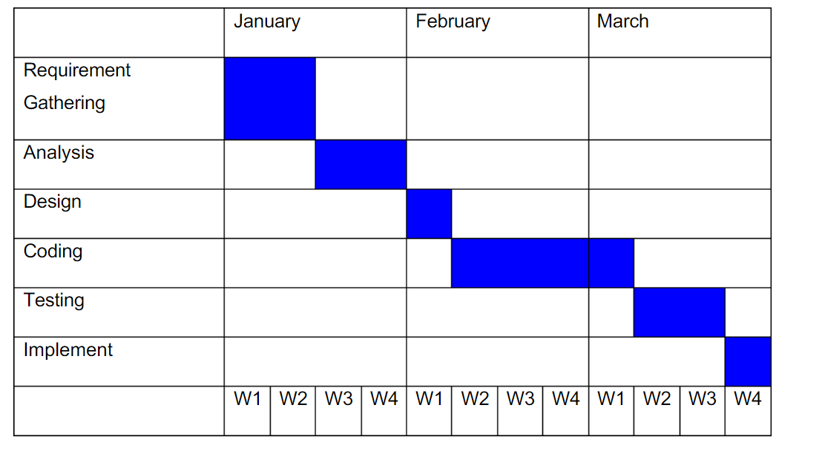

*W*i’s are weeks of the months *for i= 1,2,3,4.*

## Conclusion

The outcome of this project solves *“*CLINIC MANAGEMENT SYSTEM*”* problems that addresses on patient’s service, then all the patient’s and service provider was more beneficiary and satisfied because it helps to save resources like time, money, power and increase efficiency and effectiveness. So, it results in excellent out come to the organization.[2]

## Recommendation

We strongly recommend that one who under goes through this project can succeed, and they pay attention for Adigrat University clinic management system. Most of the time has been taken for understanding the working of existing system, how applications are written in existing system and how a third-party tool can be integrated in this system. The final recommendation towards the target group who need to work on and improving it can even think of different Billing system entirely developed for every country. If anybody can their will be functional interface that we didn’t do so using our project as a source you can improve your own system.

## **References**

|  |  |
| --- | --- |
| [1] | S. Beer, "top-healthcare-erp-systems," Clarity, 2 january 2024. [Online]. Available: https://www.clarity-ventures.com/hipaa-ecommerce/top-healthcare-erp-systems. [Accessed 22 january 2024]. |
| [2] | A. University, "Adu.edu.et," Adigrat University, 22 January 2017. [Online]. Available: http://www.adu.edu.et/about/. [Accessed 22 january 2024]. |
| [3] | *Drawbacks of existing system.* [Interview]. 17 january 2024. |
| [4] | Comparative Health Policy Library website, "Comparative Health Policy Library," 2020. [Online]. Available: https://www.publichealth.columbia.edu/research/comparative-health-policy-library/ethiopia-summary#faq-References. |

## ANNEX

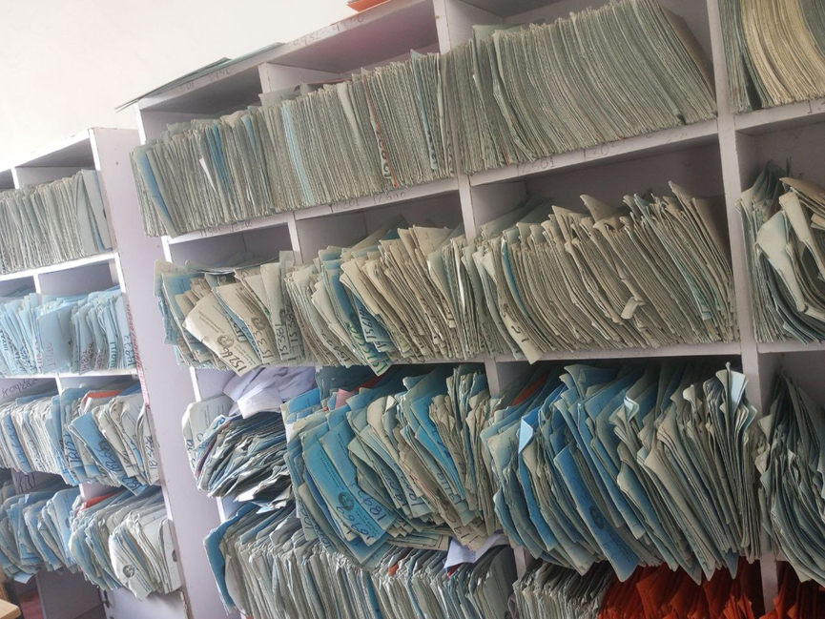

Figure 1: Clinics File cabinet (student document)

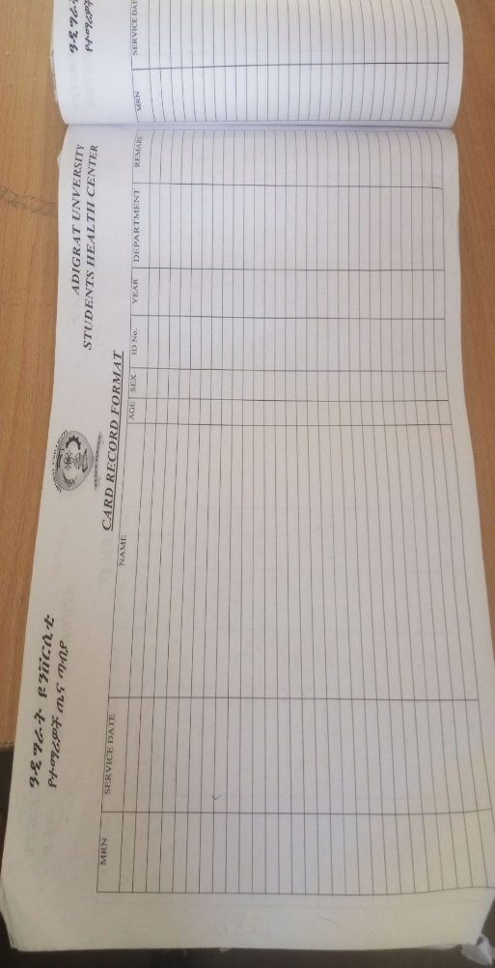

Figure 2: Patient History Form

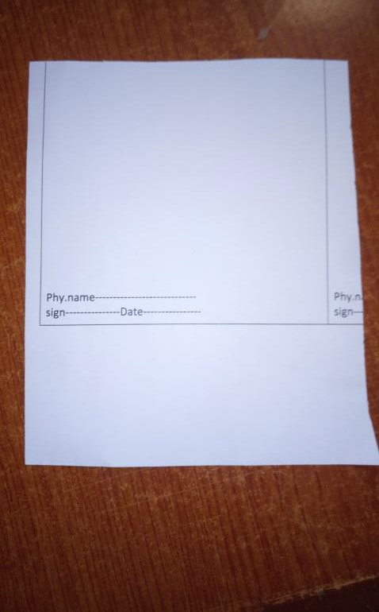

Figure 3: Drug prescription form

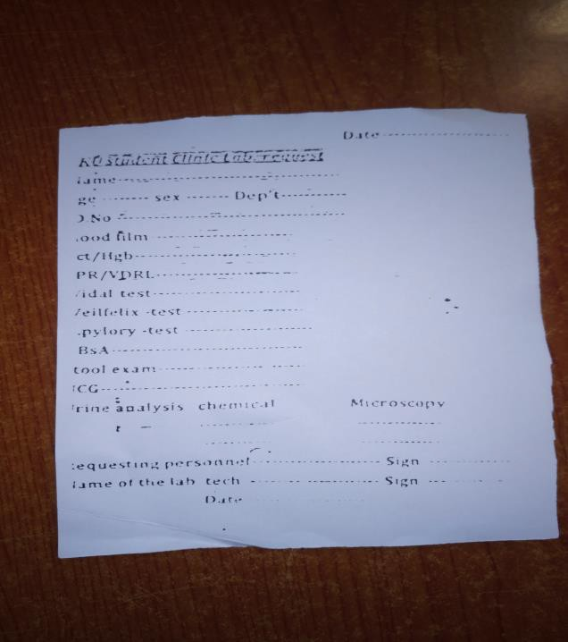

Figure 4: Lab order form